Staycation Explanation
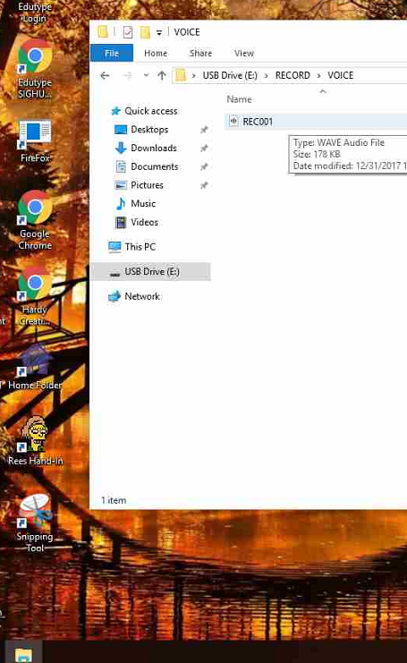
Radio Ad

- Write your radio ad down—create a written script
- Create a jingle and practice singing it. You can even bring instruments you know how to play (harmonica, ukulele, etc.) if you like.
- Use one of Mrs. Rees’ recording devices to record your voice. Go into the hall where it’s quiet to make your recording.
- Once finished, get the cord from Mrs. Rees and attach it to your computer through a USB port.
- Click on the Folder icon on your tray and find the device you just plugged in. It should be called USB Drive, probably E.
- Click on the Record folder, then the Voice folder.
- Find your recording—you may want to listen to it to be sure it’s the right one. Just right click on it and choose Play with Windows Media Player. (Choose recommended settings)
- Once you have the right file, drag it into your home folder on the desktop.
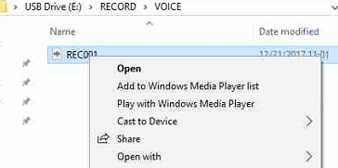
- Open Audacity and import your recording. (File, Import, Audio)
- Add music from the royalty free folder in the Staycation folder.
- Add at least one sound effect from the sound effects folder in the Information Technology folder.
- Export as an MP3 file. (File, Export, Export as MP3)
- Name it with your period and group (example, 3rd period, group 4 would be 3-4.)
- Drag it into the Rees Hand-in folder on the desktop.

