Intro to Digital Scrapbooking Using Photoshop
June, 2013
By Megan Rees
Elk Ridge Middle School
http://meganreescurriculum.weebly.com
http://www.realscrappy.blogspot.com

You only need to know how to do FIVE THINGS in Photoshop before you are ready to start creating your scrapbook. We will learn those five things today. However, two hours is not enough time to cover it all in depth. Remember that everything I teach today can be found on my blog with full instructions and even instructional videos. Please refer to my blog later when you try to remember what you’ve learned today! Also note that my blog is written for a PC—but if you are a Mac user you shouldn’t have too much trouble adapting.
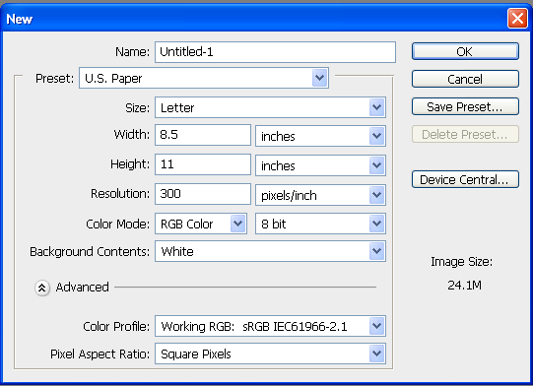
The Five Things:

- Opening & Manipulating Files
- Manipulating Layers
- Manipulating Photos
- Working with Text
- Changing Layer Styles

1: Opening & Manipulating Files

In Photoshop, go to File, New.
  - Preset – You can choose from this drop down menu if you want a specific standard size—I usually choose U.S. paper for an 8 ½ x11 size page.
  - Width and Height – here you can choose a specific size by inches or by pixels.
  - Resolution – when making a page for scrapbooking, always change the resolution to 300. Keeping it at 72 will make it print blurry—it will especially make any text blurry.
  - Color Mode – Make sure you change the mode to RGB Color. If you plan on printing your pages on your own printer, you might want to try CMYK color.
  - Background Contents – It is up to you if you want your background white, color, or transparent. I usually keep mine white or transparent.
Setting Up

You can use file, open, to get whatever it is you need. However, when you are digital scrapbooking you are constantly changing the path—getting a picture, an element, or whatever. So I like to have separate windows open on my windows tool bar so I can get easy access to everything I need.

- Minimize Photoshop so you can see your desktop
- Open your file for your images and minimize it into your toolbar. Then do the same for your kit that you are using. This way you can click and drag the needed items into Photoshop without having to do file, open and re-find the path.
  - Note: When you drag it in, if you drag it on top of your page it will bring it directly into the page as a “smart object.” This is ok, but sometimes you have issues because you can’t edit it the same as a smart object. You can always right click on the layer title in the layer menu and rasterize it so that it is no longer a smart object. Or, when you drag it in, make sure you let go on the docked toolbar.
- You should now have Photoshop open, with your kits and pictures easily accessible through your bottom toolbar.

If you would like a demonstration, go to www.realscrappy.blogspot.com, Lesson 2 for a video tutorial.

2: Manipulating Layers

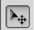
One of the fundamental things you need to understand about Photoshop is it's use of layers. Every element on a page is a different layer. Think of it like a paper scrapbook--you lay down your background paper--layer one. You lay down your first picture--layer 2. You attach a button to the picture--layer three. And so on.
Now, in Photoshop, in order to move a layer, you have to have it selected. The first tool you need to be famliar with is you move tool, which looks like this:

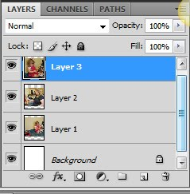
- With Photoshop open, click on your pictures file that you set up earlier.
- Click on a picture, and drag it into your Photoshop window. Pull in several—doesn’t matter which ones right now.
- Now look on your layers panel on the right side. You should see a different layer for each picture you pulled in.
- Whichever layer you click on (in the example, it’s layer 3) that is the layer that is active. If you click and drag on your page, that is the layer that will move.
- Select different layers and try moving them until you feel comfortable with selecting layers. Remember that you can right click on a layer to select it more quickly.

Here are some points to know about manipulating layers:
- Click and drag on the layer within the menu and you can change the order. Whatever layer is the highest on the list is on TOP of the layers below it. This can become important when you, say, want pictures to overlap. You can choose which layers are on top or below.
- Drag the layer on top of the trashcan icon in the lower left corner. This will allow you delete your layer.
- Hold down the ALT key and then click on your layer (in your document, not the layer menu) and drag. This will duplicate your layer.
- Hold down the CTRL/CMD key and select another layer. Now you have more than one layer selected and they will move together. Try moving them on your document and see how they go together.
- Now, with them highlighted, click on the chain link picture in the bottom of the layer menu. This has linked your highlighted layers. Now they will stay together as one layer whether you have it highlighted or not. But, you can unlink it if you choose.
- With your linked layers highlighted, press CTRL+E for a PC or CMD+E for a Mac. Now those linked layers are one forever. You can't unlink them unless you undo it. I use this a lot to link pictures with their frames or something.
A video of how to do this section can be found in Lesson 3 of www.realscrappy.blogspot.com
3: Manipulating Photos

Now you are ready to manipulate photos. We will only cover the absolute basics in this, since this is an incredibly broad topic. But this is what you need to know to make a basic page.
Cropping - The crop tool looks like this. You may recognize it, as it's the same in Word and other programs.
Now, you are going to want to use the crop tool BEFORE you pull the photo into your page. This is, obviously, because if you try to crop it AFTER, you will end up cropping your whole scrapbook page.

1. Open Photoshop
2. Create a blank page in the size you want for a scrapbook page for later.
3. Pull a picture into Photoshop, but NOT into your scrapbook page.
4. Click on the crop tool
5. Draw the size you want. You can resize it after you click and drag to make it exactly what you want.
6. Press Enter.
7. Pull it into your scrapbook page. (It may be big, but don't worry--we're fixing that next.)

That's it. However, Photoshop DOES have one useful little tool. When you click on the crop tool, notice that the options tool bar changes. If there is a certain size you want, you can enter it into the width and height boxes. I do this if I want every picture on my page to be the same proportions. Or if I am doing a full bleed picture and I want it exactly 8 1/2 x 11.

Transform - This is probably one of the most important tools you will use. Transform allows you to change the size of your pictures. The shortcut is CTRL/CMD+T, or you can go to Edit, Transform, where there are also more options like rotate, flip, and warp.
1. Go to your scrapbook page where you have pulled in the photo you just cropped.
2. Make sure you have the layer of the photo selected.
3. Press CTRL/CMD+T. You will now see that the photo has clear boxes on the corners and sides. These allow you to resize the photo.
4. Place your cursor on the corner and drag. This will change the size.
5. Press enter when finished. (Don't forget this step! Or you will be stuck in transform and won't be able to do anything else!)
Now, here are a couple tips for transforming:
- If you want the picture to keep its proportion when you resize it, hold down the SHIFT key as you click and drag.
- Always resize from the corner if you want to keep the proportion of your picture
- If you want to SKEW your picture, try holding down the CTRL/CMD key while dragging. I've rarely needed to do this, but it's good to know.
- You can also grab the corner and tilt your pictures.
Curves - Now, there are SO many ways to mess with the color and lighting on a photo--I'm only going the show you the ones that I use the most. And to me, Curves is the best way to do this. The shortcut for curves is CTRL/CMD+M. Or, you can do the long way and go to Image, Adjustment, Curves.
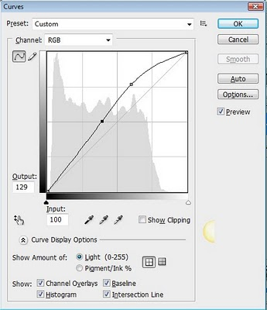
Curves allows you to change the lighting of your picture. I usually lighten up nearly every photo I've got. When you pull it up, you will see a staight line. I usually pull up the top and down the bottom, so the line looks something the picture on the right.
But, this is something you'll just have to experiment with. You'll get it. If you have CS4 or higher, you can also click on the picture of the finger, on the middle left, and then use your mouse cursor on your actual picture to lighten and darken your picture.
Usually, curves is the only adjustment I use with my pictures. There are a few others under Image, Adjustment that you will want to mess with. There are also some important features on the image menu you may also want to mess with--particularly image size and image rotation.
There is more on this section in Lesson 4 on www.reaslscrappy.blogspot.com

4: Working with Text
You should easily recognize the tool for text. Looks like this.
To begin, please open a blank page in Photoshop, the size you prefer. Remember to make SURE that you have 300 dpi and not 72, as may be the default. I really messed up a couple of pages in my first digi book by not knowing that little precious detail!
1. Click on your text tool.
2. Draw a box the size you want.
3. Now you will see a dotted square, and a blinking cursor.
4. Before you type, go to your options bar and change your options.
5. Change your font, size, and color. To change the color, just click on the black square (or it may be some other color). This is your color picker--there another such square on your toolbar, but changing that will not change your text. If you want to change your text color, make sure you select the color box on the OPTIONS toolbar at the top! When you click on the black box, it will take you to a menu where you can pretty much choose any color every thought of.
6. Once you've changed your options, just type! That's it!

A few more tips on text:
- Text will be its own layer as soon as you draw your box.
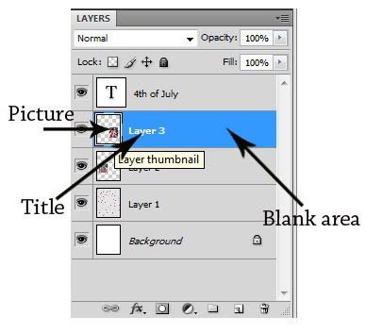
- In order to move text, you need to select it's layer and then move it. (Make sure you have the arrow select tool chosen when you move any layer)
- What if you want to change your text? On your layer, click on the large T. Clicking on the other areas of the layer will pull up other menus which we will discuss in the next lesson. When you click on this, your text will be highlighted and you can go back and change it.
- If you do CTRL/CMD+T, this will transpose your text just like your photos. You can change the size of the box, you cannot change the text itself.
5: Changing Layer Styles
Technically, you now know enough to make a page. But layer styles are also pretty darn important, and can make a huge difference in making your page look better.
You are now going to open the layer styles menu. On your layer, there are basically there parts to it. And double clicking on certain parts will get you certain menus.
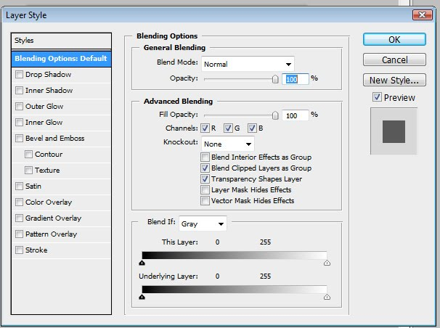
To get the Layer Styles menu, double click on the BLANK area of the layer you want. This will get you this menu:
Move the menu over so you can see the layer you have selected. Try out several of the style options. I suggest you check out Drop Shadow, Bevel & Emboss, and Stroke. When you click on the actual WORD, you will get additional options for that particular feature.
For a more full explanation of this section, and a video, check out Lesson 6 at www.realscrappy.blogspot.com
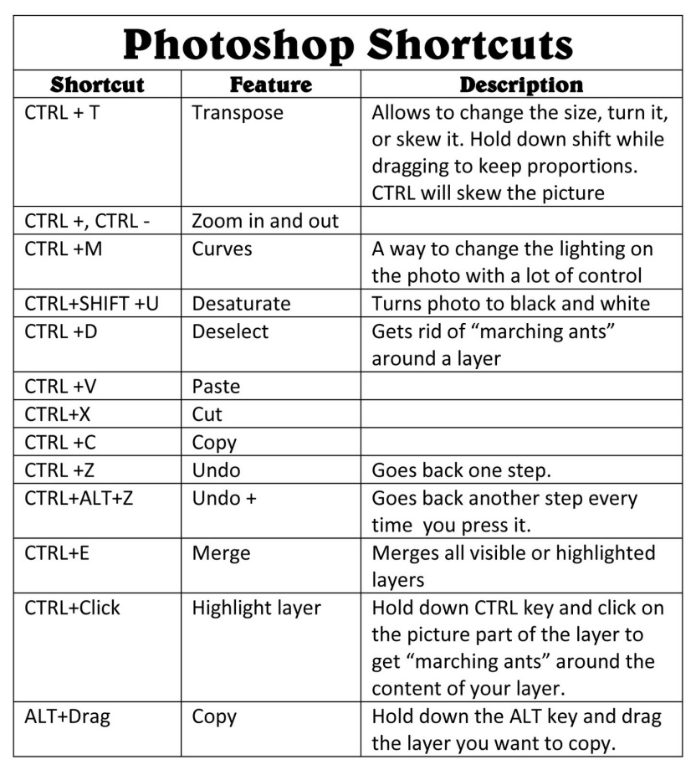
Now that you know the Five Things, you are ready to make an actual page! Using a kit, pull in your background paper. Maybe add a ribbon and put a drop shadow on it from your layer style. Pull in your pictures and crop and resize them. Add a stroke around the edges of a matching color. Pull in a few more elements from the kit and place them nicely. Add a textbox and create your title, adding a bevel or shadow to it to make it look nice. Add a smaller text box with a bit of journaling about the page. And boom! You are done! There is A LOT more to it than this, and you can learn more details on my blog—feel free to go through each lesson until what you learned today is just second nature!
Additional Information:
Printing
There are basically three ways to print:

Print them Yourself – The most expensive and convenient option. If you happen to own a nice laser printer or even a photo printer, and don’t mind the ink cost, this can be a great way of doing it. You'll also have to convert to 8 1/2 x 11 pages, unless you happen to have a 12x12 printer, but I doubt you would. You'll also have to buy an album with page covers to slip your pages into. Those albums can cost anywhere from $20 - $50, depending on where you go.

Print in a Bound Book

This is my option. To me, it's the only option. Because it looks SO GREAT! Now, there are a lot of websites out there that offer this service. I've looked into a few. I use Cherishbound because their prices are reasonable and they are a Utah company. My books cost anywhere from $80 – $120 to print, but that is for books with 50-100 pages! Cherishbound requires a consultant to sign up with, but because of my blog, they have given me a special login for those who learn of their company through me. If you want a Cherishbound account, go to http://www.cherishbound.com/new.php?eqs=NzA1, or just go to Lesson 12 on my blog and click on the Cherishbound link. (I get no compensation for you signing up!)

There are other companies like Heritage Makers, Snapfish, Blurb, Mixbook and Shutterfly that are also great. They all do different sized books—I prefer the 8 ½ x 11 but most digi scrappers don’t so it’s hard to find a company that will print them! 12x12 is much more common.

Many of the companies above have options where you can create your digital page right there on their site without Photoshop. You are much more limited, but it’s much quicker and simpler if you don’t want to use Photoshop. If you want to use Photoshop, when making your book and selecting a template, choose the “full bleed” option, which is just one giant picture that is the same size as your page. Then upload your page and pull it in.

Print by the Page

This is a great option if you want to spread out the cost of printing page by page. A book, you have to pay for all at once, and you have to wait till you are ready to print it to see any of it hard copy. Printing by the page is simple—just save your files and take them to Costco or upload them online to a place like www.scrappingsimply.com or www.persnicketyprints.com. You will also have to buy an album with page protectors.

Kits
A kit is a set of files which include papers, elements, tags, ribbons, alpha, and so forth, all of which compliment each other. You do not need kits to digital scrapbook, but they do make it a LOT easier. There are a lot of places where you can get free kits online. Some free kits are better than others, and if you want really good kits, pay for them. But I rarely pay more than $4.00 per kit. Remember that once you buy it, it’s yours forever!

Here are some of my favorite kit sites:

www.gottpixel.com – This is my current favorite—they have a lot of sales. My favorite designers are Lindsay Jane and Connie Prince. They have a fun forum where you can post questions and your layouts.
www.pickleberrypop.com – I haven’t bought as much here, but they are great!
www.designsbykrista.net/shop/ - I love Krista’s stuff. Her kits are so cheap, but they are also smaller. Some are only $2.00, and I use them A LOT!
www.twopeasinabucket.com – This site doesn’t have much of a digital store (anymore) but they DO have a digital scrapbooking forum that is AWESOME. Ask any question about something you are trying to figure out, and I guarantee you’ll have an answer within an hour. A very active board and some awesome people on it!
www.peppermintcreative.com – A great site for freebies. Just click on Freebies and download the one they have for the month. High quality, very cute.
www.digifree.com – This site is strictly for freebies. There are a ton—but don’t download everything! Just get what you actually like and what is high quality.
www.summertimedesigns.blogspot.com – This lady has some amazing freebies. They take FOREVER to download but they are worth the wait! I suggest you get your first kits here.

Remember—there is A LOT more helpful information on my blog! I’ve totally condensed this, and it’s STILL a novel. So, if you really enjoyed this class, go to www.realscrappy.blogspot.com, and start will lesson1. Right now my blog has over 30 tutorials (many with videos) as well as fun freebie downloads and projects that I have done using Photoshop.

