COMPUTER TECHNOLOGY
Semester Test Review

__________________________________________
Student Name

Excel/Spreadsheet Review
What is a worksheet? ___________________________________________________________________

Excel spreadsheets are made up of _____________________ and ___________________________.

When a row and a column meet it creates a ______________________________

True or False: Rows run left to right and are labeled with letters? __________________________

True or False: Columns run horizontal and are labeled with letters? ________________________

Draw an example of the following charts that can be created in Excel.

Bar Chart | Column Chart
Line Chart | Pie Chart

What is the purpose of filtering information in a spreadsheet? ______________________________
__________________________________________________________________________________________

Give 3 examples of data being sorted in descending order.
- ______________________________________
- ______________________________________
- ______________________________________

Give 3 examples of data being sorted in ascending order.
- ______________________________________
- ______________________________________
- ______________________________________

What column controlled the sort in the spreadsheet below? _______________________________

Was it sorted in ascending or descending order? ________________________________________

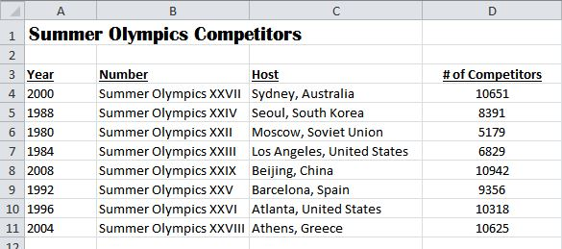

Identify (Circle) if the following are functions or formulas.

Function/Formula | Function/Formula | Function/Formula | Function/Formula | Function/Formula
=B4+C4 | =SUM(A3:A12) | =(C2+C5)*B12 | =MAX(C8:C12) | =COUNT(D3:D6)

In order to make a cell absolute you must include what symbol? _____________________

What is the keyboard shortcut to make a cell reference absolute? ________________

In order to tell what colors mean in a spreadsheet you should look at the ___________________

Database/Access Review
Label the parts of an Access 2010 window.
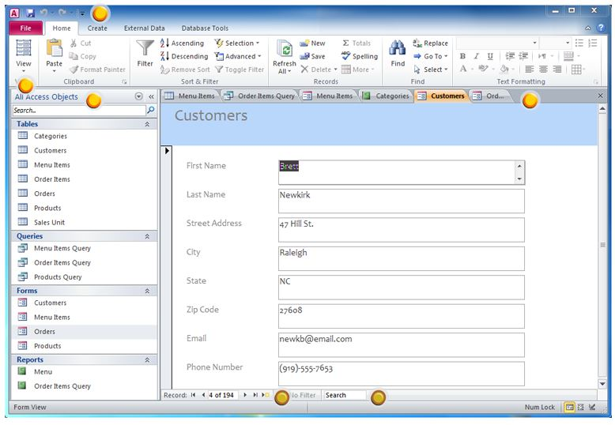

This part of Access contains all of the objects contained in your database. _________________

Draw a picture of what button you would push to go to a next record in your database.

Match the terms with their definitions.

_____ 1. Field | a. A collection of records
_____ 2. Record | b. Categories for records
_____ 3. Query | c. Finding certain records that meet a need
_____ 4. Table | d. Information for a particular file

Internet Review
In order to create a webpage it needs to be written in this language. ______________________

The address for a website is called Uniform Resource Locator. What is the abbreviation for a web address? _________________________

Tell what type of domain each website would have.

Website | Domain
Department of Homeland Security
University of Utah
Google
The Road Home

How do you know if there is a hyperlink on a webpage? __________________________________
_________________________________________________________________________________________

Web browsers are programs that allow you to view information on the web. What web browser do you use the most? ______________________________________________

When you first open a web browser a webpage opens up. What is that web page called? ______________________________________
If you need to communicate with a company in another country what might be a good option? _________________________________________________
If a teacher wanted to record class for students who were absent, a good option might be to create a ______________________.

When narrowing down searches on the Internet you use ____________________ ____________________.
Examples of Boolean operators are:
- ______________________________________
- ______________________________________
- ______________________________________
- ______________________________________
What does AUP stand for? _______________________________________________________________
What is an AUP (details)? ________________________________________________________________
_________________________________________________________________________________________
Have you ever signed an AUP? Explain. __________________________________________________
_________________________________________________________________________________________
What is the difference between freeware and creative commons license? _________________
______________________________________________________________________________________________________________________________________________________________________________________________________________________________________________________________________________
What is plagiarism and how do you protect yourself from it? _______________________________
______________________________________________________________________________________________________________________________________________________________________________________________________________________________________________________________________________

Email Review
In your own words, what is the difference between CC and BCC? _________________________
____________________________________________________________________________________________________________________________________________________________________________________

If you want to reply to everyone is an email, you use _______________________________________
If you want to reply just to the person who sent the email, you use __________________________

When you receive unwanted emails, such as advertisements, this is known as _______________
What is some proper etiquette you should use when using email?
- ______________________________________
- ______________________________________
- ______________________________________

PowerPoint
Why are layouts important when it comes to PowerPoints? ________________________________
____________________________________________________________________________________________________________________________________________________________________________________

What are the three types of views in PowerPoint?
- ______________________________________
- ______________________________________
- ______________________________________

Explain when you would use each of those views when working in PowerPoint?
Slide Show View
Normal View
Slide Sorter View
What is the difference between a slide transition and animation? __________________________
______________________________________________________________________________________________________________________________________________________________________________________________________________________________________________________________________________

Why would speaker notes be important when presenting a PowerPoint? ___________________
____________________________________________________________________________________________________________________________________________________________________________________
If you want to print 1 slide per page select ________________________________________________
If you want to print multiple slides per page select ________________________________________

Word Review
In Word, a red line means there is a _______________________ error and a green line means there is a ________________________________.
When you copy items in Word, it goes to a temporary storage area called the ___________________________________ until it is pasted into your document.
What type of spacing was applied to each paragraph?
_____ 1. Single Space (Ctrl + 1) | A. U.S. and Spain signed a treaty that set boundaries. Spain gave up land claims in Florida and Oregon. Russia later gave up its class out of Alaska.
_____ 2. 1.5 Space (Ctrl + 5) | B. U.S. and Spain signed a treaty that set boundaries. Spain gave up land claims in Florida and Oregon. Russia later gave up its class out of Alaska.
_____ 3. Double Space (Ctrl + 2) | C. U.S. and Spain signed a treaty that set boundaries. Spain gave up land claims in Florida and Oregon. Russia later gave up its class out of Alaska.
What type of alignment was applied to each paragraph?
_____ 1. Left Align (Ctrl + L) | A. U.S. and Spain signed a treaty that set boundaries. Spain gave up land claims in Florida and Oregon. Russia later gave up its class out of Alaska.
_____ 2. Right Align (Ctrl + R) | B. U.S. and Spain signed a treaty that set boundaries. Spain gave up land claims in Florida and Oregon. Russia later gave up its class out of Alaska.
_____ 3. Justify (Ctrl + J) | C. U.S. and Spain signed a treaty that set boundaries. Spain gave up land claims in Florida and Oregon. Russia later gave up its class out of Alaska.
_____ 4. Center (Ctrl + E) | D. U.S. and Spain signed a treaty that set boundaries. Spain gave up land claims in Florida and Oregon. Russia later gave up its class out of Alaska.

What are the types of lists you can do in Word?

- ______________________________________
- ______________________________________
- ______________________________________

Use the paragraph below to answer the following questions.
As you work for higher skill, remember that how well you key fast is just as important as how fast you key. ²How well you key at any speed depends in major ways upon the technique or form you use. Bouncing hands and flying fingers lower the speed, while quiet hands and ³low finger reaches increase speed.

Few of us every reach what the experts ⁵believe is perfect technique, but all of us should try to approach it. We must realize that good form is the secret to higher speed with few errors. We can then focus our practice on the improvement of the features of good form that will bring success.

What type of indent was applied in the second paragraph? ______________________________

What formatting was applied to 2? _____________________________________________

What type of indent was applied in the first paragraph? ___________________________________

What type of formatting was applied to 3? _______________________________________________

What type of formatting was applied to 5? _______________________________________________

What type of wrapping was applied to both paragraphs? _________________________________

Letter Review
Label the parts of the letter below.

SOUTH JORDAN MIDDLE SCHOOL
10245 S. 2700 W.
South Jordan, UT 84084
Current Date
Mr. Leslie D. Banks
George Washington High School
2165 E. 2700 S. Street
Salt Lake City, UT 84109-3720
Dear Mr. Banks:
You question about the effect of word processing equipment on the need for keying accuracy is a good one.

Accuracy of documents processed is just as vital now as ever before. The case with which keying errors can now be corrected, however, has shifted the emphasis from number of input errors made to skill in finding and correcting these errors.
A major weakness of those who take employment tests is their inability to detect and correct the errors they make. Therefore, we suggest that employee training should emphasize proofreading and error correction rather than error-free initial input.

A grading system rewarding efficient proofread and correction skills instead of penalizing errors of initial input is worthy of your serious consideration.
Cordially yours,
Jamie L. Houston
Office Manager
amh

Reference initials are always formatted as ________________________________________________

Give an example of when you would use attachment in a business letter? __________________
__________________________________________________________________________________________

Give an example of when you would use enclosure in a business letter? ___________________
_________________________________________________________________________________________
In Block format you should use a __ after the salutation and a ___ after the complimentary close.

What type of document can you create using a template? _____________________

Basics Review
What is the difference between a LAN and a WAN? ______________________________________
____________________________________________________________________________________________________________________________________________________________________________________
What does LAN stand for? _______________________________________________________________
Give an example of a LAN. ______________________________________________________________
What does WAN stand for? ______________________________________________________________
Give is the largest example of a WAN? ___________________________________________________
What is RAM used for? ___________________________________________________________________
True or False When the computer is turned off, memory stored in the RAM is saved.
When is ROM used in a computer? _______________________________________________________
Why is the operating system useful for a computer? _______________________________________
__________________________________________________________________________________________
What is a network? ______________________________________________________________________
__________________________________________________________________________________________
Is the classroom an example of a network? Explain. _______________________________________
__________________________________________________________________________________________
What is an input device? ________________________________________________________________
__________________________________________________________________________________________
What is an output device? _______________________________________________________________
__________________________________________________________________________________________
Give examples of input and output devices in ascending order.
Input Devices | Output Devices
1. ________________________________________ | 1. ________________________________________
2. ________________________________________ | 2. ________________________________________
3. ________________________________________ | 3. ________________________________________
4. ________________________________________ | 4. ________________________________________

____________________ devices can add input, output, and storage capabilities to your computer.
When the computer is turned off, what are four options you can use to save your data?
- ______________________________________
- ______________________________________
- ______________________________________
- ______________________________________

The above devices are also known as _____________________________________________________
When would you use the Save option? ____________________________________________________
__________________________________________________________________________________________
When would you use the Save As option? ________________________________________________
__________________________________________________________________________________________
Fill in the table below.
Memory Name | Memory Size
_________________________________________ | Each 0 or 1
Byte | __________________________________________
Kilobyte
__________________________________________ | 1 million bytes
__________________________________________ | 1 billion bytes
Terabyte | __________________________________________
What are the 3 most common application software used in business today?
- ______________________________________
- ______________________________________
- ______________________________________
What might cause your computer so slow down? ________________________________________

Types of Computers
Match the computer to the correct definition.
Type of Computer | Definition
_____ Desktop | A. PC based on the individual needs of the users.
_____ Workstation | C. Used for specialized tasks that require high processing speeds
_____ Microcomputer | F. Portable, compact computer that can run on an electrical wall outlet or a battery unit
_____ Notebook | D. The CPU is housed in a vertical or horizontal system unit and it fits on a desk and run on power from an electrical wall outlet.
_____ Server | E. Supplies data usually through a LAN

Types of Viruses
What is a computer virus? ________________________________________________________________
__________________________________________________________________________________________

What type of file extensions do computer viruses usually attach themselves to? __________________________________________________________________________________________
Why is antivirus software so important? ___________________________________________________
__________________________________________________________________________________________
Give 3 examples of antivirus software?
- ______________________________________
- ______________________________________
- ______________________________________

