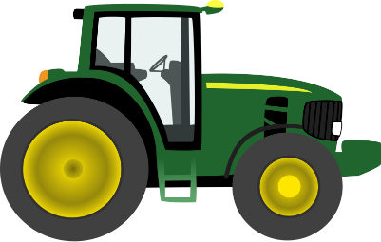
Agricultural Careers

Find someone who…

1 | Makes more money than you
2 | Makes less money than you
3 | Works with soil
4 | Works with trees
5 | Works with animal health
6 | Uses math
7 | Works with water
8 | Works with aquatic animals
9 | Has a Bachelor’s degree
10 | Has a Master’s degree
11 | Has a PH.D.
12 | Works with flowers
13 | Has a job outlook of higher than 10%
14 | Has a job outlook of less than 2%
15 | Works with wild animals
16 | Makes less than $40,000
17 | Uses a computer at work
18 | Measures stuff
19 | Spend a lot of time outdoors
20 | Has a career you think is cool
21 | Has a career you could NEVER do

