C:\Users\Megan.Rees\AppData\Local\Microsoft\Windows\Temporary Internet Files\Content.IE5\TYZFSBOL\MC900432465[1].wmf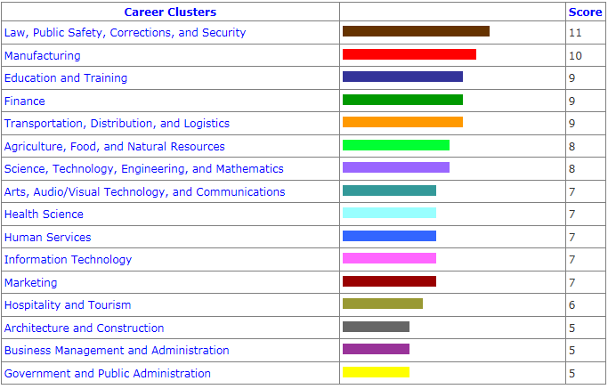C:\Users\Megan.Rees\AppData\Local\Microsoft\Windows\Temporary Internet Files\Content.IE5\TYZFSBOL\MC900434391[1].wmfInstructions: Go to Utahfutures.org. Click on “Browse Utahfutures.org”. Scroll over the Assessments tab, and then click “Career Cluster Inventory.” Select “Rate these activities”. Answer the questions that follow as accurately as possible. There are 80 questions, but it should only take a few minutes to answer your interest level for each activity. Press “Get Results” when you finish all questions.

Click on your highest scored career cluster. Read the overview

**Highest Scored Area**: ___________________________________________ Score: _________

Occupations: Click on Occupations and choose three careers from the list that interest you. Click on that career and answer the questions below.

|  |  |  |  |  |
| --- | --- | --- | --- | --- |
|  | Career Title | Education Level (Preparation) | Yearly Income  (Wages, Salt Lake City, End of career) | Employment and Outlook (Look up Metro) |
| 1 |  |  |  |  |
| 2 |  |  |  |  |
| 3 |  |  |  |  |

**Second Highest Scored Area**: _______________________________________ Score: ___________

Occupations: Click on Occupations and choose three careers from the list that interest you. Click on that career and answer the questions below.

|  |  |  |  |  |
| --- | --- | --- | --- | --- |
|  | Career Title | Education Level (Preparation) | Yearly Income  (Wages, Salt Lake City, End of career) | Employment and Outlook (Look up Metro) |
| 1 |  |  |  |  |
| 2 |  |  |  |  |

**Third Highest Scored Area**: _______________________________________ Score: ___________

Occupations: Click on Occupations and choose three careers from the list that interest you. Click on that career and answer the questions below.

|  |  |  |  |  |
| --- | --- | --- | --- | --- |
|  | Career Title | Education Level (Preparation) | Yearly Income  (Wages, Salt Lake City, End of career) | Employment and Outlook (Look up Metro) |
| 1 |  |  |  |  |
| 2 |  |  |  |  |

C:\Users\Megan.Rees\AppData\Local\Microsoft\Windows\Temporary Internet Files\Content.IE5\42LGRPXN\MC900432479[1].wmfC:\Users\Megan.Rees\AppData\Local\Microsoft\Windows\Temporary Internet Files\Content.IE5\3RBWQTW1\MC900432469[1].wmf

Of the seven careers I have researched, I am most interested in: ___________________________________